TX-300 Intelligent Metal Conductor Resistivity Measuring Instrument



Xiamen Tianyan Instrument Co. , Ltd.

Contents
1 Overview 1
2 Main features of the instrument 1
3 TX-300A/B Main Parameters 2
4 Components of the instrument 3
5 Instruction for Use 4
5.1 Keyboard layout 4
5.2 Power on/off operation 4
5.3 Measurement 5
5.3.1 Measurement preparation 5
5.3.2 wire parameter meas 8
5.3.3 conduc/resis meas 10
5.3.4 DC resistance meas 11
5.3.5 Conduc DC resist meas (only for B model) 11
5.3.6 Settings 12
5.3.7 Print 14
5.4 Menu 15
5.4.1 Sub-interface of Meas mode option 16
5.4.2 Sub-interface of Meas item option 17
5.4.3 Sub-interface of Calibration 18
5.4.4 Sub-interface of Temp. comp mode 20
5.4.5 Sub-interface of Temp. coeff set 20
5.4.6 Sub-interface of Printing setting 21
5.4.7 Sub-interface of Date/time adjust 22
5.4.8 Sub-interface of Data handle mode 22
5.4.9 Sub-interface of Backlight set 24
5.4.10 Sub-interface of Buzzer set 25
5.4.11 Sub-interface of Language set 25
5.4.12 Sub-interface of Meas fixt select (only for B model) 26
5.5 Charging battery 26
6 Attentions and maintenance 27
7 User notice 27
Appendix 1: Introduction of printer operation 29
Appendix 2: Table of the conductivity and temperature coefficient of commonly used materials 31

1 Overview
TX-300 A,B series of intelligent metal conductor resistivity measuring instrument are patented products of our company. They are the only portable and fully automatic instruments in the world, for measuring resistivity and conductivity of wire and bar materials. The design of the high-tech products adopts current-voltage four-terminal measuring method, advanced electronic techniques, singlechip technique and automatic detection technology. Their performances completely accord with the technical requirements of GB/T3048.2 and GB/T3048.4. The products can be widely applied in the fields of metallurgy, electric power and electrical engineering, wire and cable, electrical machines and equipments, colleges and universities, research institutes, etc.

2 Main features of the instrument
- Combining advanced electronic, singlechip and automatic measurement techniques in one instrument, with superior automatic functions and simple operation.
- All measured numerical values can be obtained by just one press on the key without any calculation. The instrument is adequate for continuous, fast and accurate measurements.
- Battery power supply has small size thus easy to carry, suitable for indoor and open-field use.
- With large screen and font. Can display measured values and auxiliary parameters at the same time, including resistivity, conductivity, resistance, temperature, measuring current and temperature compensation coefficient.
- One instrument has multiple applications, and has three measurement interfaces: interface of conductor resistivity/conductivity measurement, interface of wire/cable comprehensive parameter measurement and interface of wire/cable direct-current resistance measurement (TX-300B model).
- The functions of automatic constant current selection, automatic current reversal, automatic zero point correction and automatic temperature compensation are maintained for every measurement, to guarantee the accuracy of measured value.
- Special portable four-terminal measuring fixture is suitable for fast measurements of different materials and the wire/bar with different standards.
- The build-in data accumulator can record and save 1000 groups of measuring data and parameters. Connecting it to the host computer, the complete report can be generated.

3 TX-300A/B Main Parameters
Parameter  Item | Resistivity | Conductivity | Resistance
Measuring range | 0.01µΩ·m～2.5µΩ·m | 0.4MS/m～100MS/m  0.69%IACS～172%IACS | 0.1µΩ～150Ω
Resolution | 10^{－4}～10^{－6}µΩ·m | 0.01～0.001%IACS | 0.1µΩ（I=1A）
Precision | ±0.25%  ±(0.1%＋$\frac{0\text{.}\text{15}}{\text{Rx}}\text{100}\text{\%}$) when conductor resistance $\text{Rx}$＜100µΩ | ±0.25%  ±(0.1%＋$\frac{0\text{.}\text{15}}{\text{Rx}}\text{100}\text{\%}$) when conductor resistance $\text{Rx}$＜100µΩ | 100µΩ～150Ω：±0.15%  $\text{Rx}$＜100µΩ：±($\frac{0\text{.}\text{15}}{\text{Rx}}\text{100}\text{\%}$)
Temperature measurement | －10℃～＋55℃ Precision ±0.2℃(0℃～＋40℃)
Internal constant current of the instrument | 16µA level～1A level（automatic selection according to the measuring requirement）
Wire/cable measuring fixture | - Equipped with 300mm portable measuring fixture，for wire diameter：Ø0.1mm～Ø14mm  - Can select 1000mm standard measuring fixture or other non-standard fixture with different size (only for B model)  - Equipped with a special wire for measuring coiled wire/cable (only for B model)
Automatic temperature compensation | The measured value will be automatically compensated to the value at 20℃.
Wire/cable measuring items | - Resistivity ρ_{v}, conductivity σ, resistance R, resistance of unit length R_{l}, mass resistivity ρ_{m} of solid conductors  - Wire/cable direct-current resistance, resistance of 1000m length (only for B model)
Printout data | Date, time, temperature correction coefficient α, wire specifications, and all measured values of conductor and wire/cable
Normal working environment | Temperature: 0℃～＋40℃; relative humidity: 0～80%
Display | Large LCD screen with backlight, can display multiple measuring parameters at the same time.
Power supply | 7Ah/7.4V chargeable lithium battery; battery power supply only, average working hour over 15 hours
Internal memory | Can save 1000 groups of measured data.
PC communication mode | RS232 serial port
Weight | Host：2.2kg Portable measuring fixture：1kg
Host size | 285(W)*158(H)*120(D)
Host shell | Shock-resistance engineering plastic
Packaging and protection | Highly shock-resistance and portable aluminium alloy suitcase, containing the host, measuring fixture, charger, communication cable, calibration resistor, operation manual and CD, mini-printer, four-terminal resistor measuring clamp and temperature sensor.

4 Components of the instrument
- Instrument host
- 300mm portable measuring fixture
- 1000mm standard measuring fixture (can be purchased only for B model)
- Special wire for measuring coiled wire/cable (only for B model)
- Four-terminal resistor measuring clamp
- Calibration resistor
- Host charger 8.4V/1A
- Portable printer, printer charger 8.5V/4A，printer communication line
- RS232 uploading communication line
- Temperature sensor
- Aluminium alloy suitcase
- Operation manual and CD

5 Instruction for Use

5.1 Keyboard layout
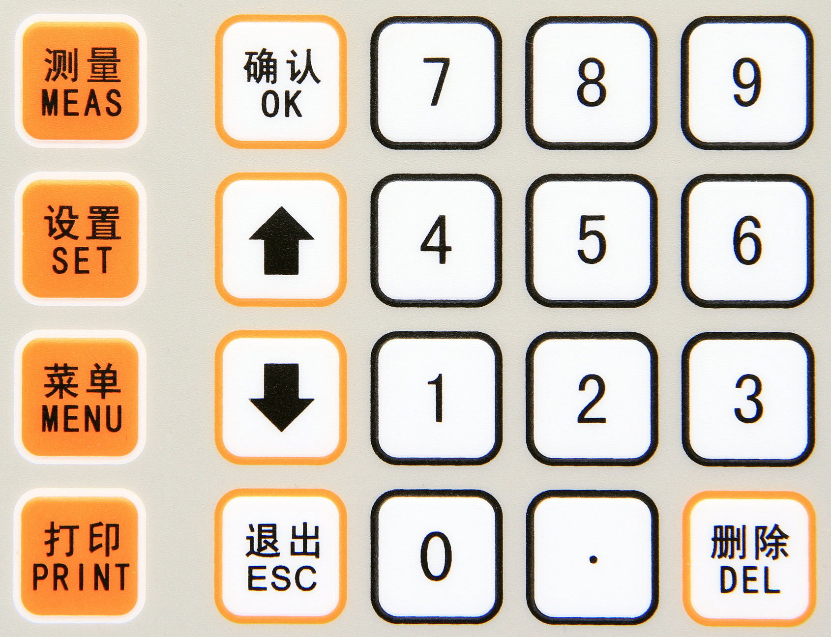
Introduction of keys:
- ‘ON/OFF’ —— power key, at the bottom left of the LCD screen
- ‘测量MEAS’—— measurement key
- ‘设置SET’ —— parameter setting key (valid on main measuring interface)
- ‘菜单MENU’ —— menu key
- ‘打印PRINT’ —— print key (valid on measuring interface or when making inquiry)
- ‘确认OK’ —— confirm key
- ‘↑’ ‘↓’ —— moving up key and moving down key
- ‘退出ESC’ —— exit key
- “删除DEL”—— deletion key
- ‘0~9’，‘．’ —— numerical keys and decimal point key

5.2 Power on/off operation
When the instrument is at power off state, press power key ‘ON/OFF’ and keep ‘ON’ side of the key down, the instrument is energized to start. After about 10 seconds, the screen displays ‘initializing’ warming-up progress bar. The starting-up interface is shown in the following illustration.
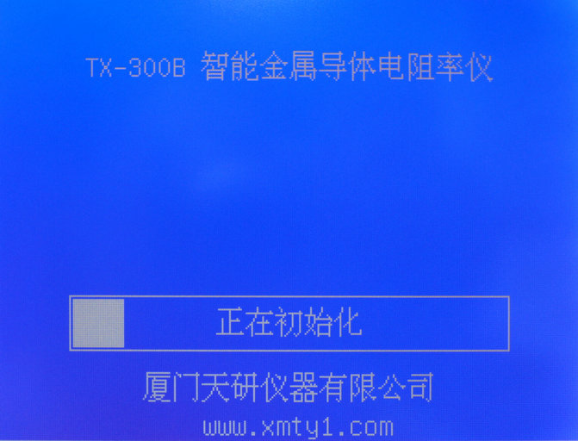
The full warming-up time for initialization is 5 minutes. After completion, it automatically enters ‘measurement main interface’. During initialization period, if one wants to skip warming up and enter the measurement main interface directly, one can press measuring key “MEAS’ once.
At power on state, press power key ‘ON/OFF’ and keep ‘Off’ side of the key down, the power is cut off and the instrument is shut down.

5.3 Measurement
Instrument display interface statement to explain

statement | explain
wire parameter meas | wire comprehensive parameter measuring
conduc/resis meas | conductivity/resistivity measuring
DC resistance meas | DC resistance measuring
conduc DC resist mea | conductor DC resistance measuring
Problem in meas fixt connect | Problem in measuring fixture connection
Meas mode option | measuring mode option
Meas item option | measuring item option
Temp. comp mode | temperature compensation mode
Temp. coeff set | temperature coefficient setting
Date/time adjust | date/time adjustment
Backlight set | LCD backlight setting
Meas fixt select | measuring fixture selection
Language set | language setting
save single meas tape | save single measuring tape
save average meas value | save average measuring-value tape
inp value of std resist | input the value of standard resistance
manual temp. input | manual entering temperature value
equipped temp. sensor | equipped temperature sensor

5.3.1 Measurement preparation

5.3.1.1 Entering measurement main interface
After entering the system or at any interface, pressing “ESC” key several times can return to the selected ‘measurement main interface’. Then the system is in the measurement waiting state and displays ‘measurement main interface’ (The details of the selection of measurement main interface is presented in 5.4.2 ‘Meas item option’.)
When the measured result is displayed on the screen, the measured values will be deleted by pressing “ESC” key. Then the system will return to measurement waiting state and display measurement main interface. If press ‘MENU’ key or ‘SET’ key, the measured value will also be deleted.
Only in the measurement waiting state, the temperature value T_{A} shown on the interface will vary instantly with the ambient temperature.

5.3.1.2 Connection of the temperature sensor
Insert the plug of the temperature sensor into the socket at the lower part of the back of the host, and place the sensing tip of the sensor on the left mount of the host.

5.3.1.3 Connection of the measuring fixture and the host
Connect the aviation plug of the measuring fixture with the POTENTIAL end of the host, the red line BNC plug with the red CURRENT end of the host and the black line BNC plug with the black CURRENT end of the host.

5.3.1.4 Connection of the conductor (wire) and the measuring fixture
When measuring conductor (wire), firstly straighten the conductor and fix it with the two fixed potential clamps, then use the red and black current clamps to clamp the two ends of the conductor respectively. The distance between the current clamping point and the potential clamping point is usually over 1.5 times of the conductor perimeter. The detailed connection is illustrated below.

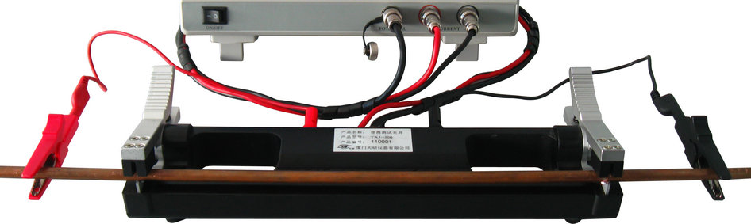

5.3.1.5 Connection of the resistor and the measuring fixture
When measuring four-terminal resistor, firstly insert the plugs of red and black clamps into potential chucks of the measuring fixture respectively, with the red potential clamp and the red current clamp on the same side, and the black ones on the other side. Then make the red and black current clamps clamping the current ends of the four-terminal resistor and the red and black potential clamps clamping the potential ends of the four-terminal resistor. The connection specific is as shown below.
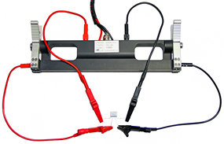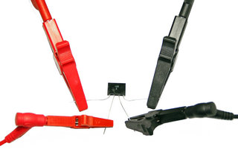

5.3.1.6 Connection of the special clamps for measuring DC resistance of wire/cable coil
Direct-current resistances of wire and cable can be measured using measuring fixture over one meter long and also can be measured using special clamps for measuring cable coil connected to the back port of the host. The connection is shown in the following illustration. The plugs of the red clamps are connected to C1 and P1, while the plugs of the black clamps are connected to C2 and P2.

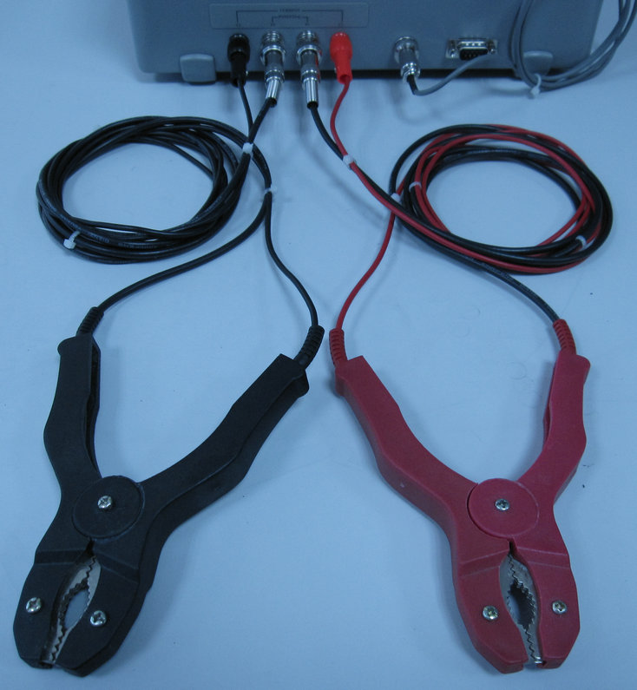

5.3.1.7 Attentions in measuring process
To insure accurate measurement, the measuring process should meet the following requirements:
- When fixing a conductor to the measuring fixture by hands directly, hand temperature will affect the conductor temperature. The degree of the influence depends on the fixing time and the diameter of the conductor. Therefore every time after the conductor is fixed and before the measurement is carried out, it is better to wait for a little while till the temperature of the conductor is balanced with the ambient temperature.
- By all means, avoid using hands to touch potential chuck of the measuring fixture and the tip of the temperature sensor.
- During measurement, the temperature sensor should be placed far from the radiator and stove, and avoid direct sunlight.
- The ports ‘POTENTIAL’ and ‘CURRENT’ at the back of TX-300B for connecting measuring clamps are linking to the corresponding ports at the front panel of the host. Hence it is prohibited to connect the measuring fixture or measuring clamps to the front and back ports at the same time.

5.3.2 wire parameter meas
Firstly, set the measurement main interface to ‘wire parameter meas’ illustrated below (see 5.4.2 for detailed setting method).
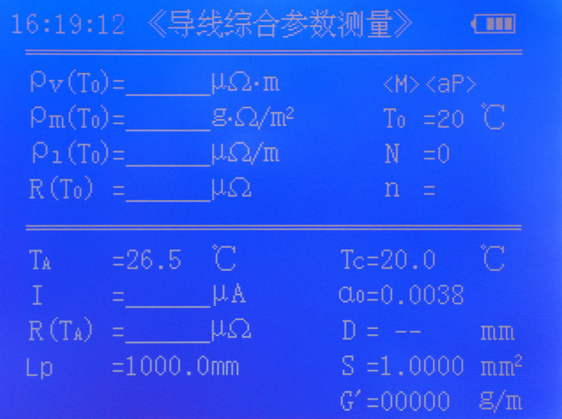
On the upper left corner, the screen displays the current time (24-hour system). On the upper right corner it displays the electricity quantity of the battery: 4 grids represent full quantity, and 0 grid indicates the battery must be charged. In the latter situation, the buzzer will beep three times continuously in every 5 minutes to prompt the user to charge the battery.

5.3.2.1 Instruction of the instrument state
- <M>——While on display, automatic data saving function is turned on, i.e., after one measurement the data group will be saved once (see 5.4.1.1 for details). Otherwise the data will not be saved.
- <mP> or <aP>——While on display, printing function is turned on, otherwise it is turned off (see 5.4.6 for details). <mP> represents manual printing. When the measured data are on display, pressing ‘PRINT’ key will print out current data. <aP> represents automatic printing. When a measurement is finished, the data will be printed out automatically without pressing ‘PRINT’ key. Before printing, make sure the portable printer equipped for the instrument is connected properly.
- T₀——Standard temperature 20℃；
- N——Number of measured data groups saved in the instrument. The maximum is 1000 groups.
- n——When the measurement is for average values, n represents the times of measurement already done. When n reaches the value set in ‘Meas mode option’ of ‘menu’, it represents the current number of times. The data measured in n times, except the set parameters, will be automatically converted to average value. The original symbols of the measured values will add ‘ˉ’, such as resistivity ρ₀ becomes ρ₀. When conducting single measurement, n will not show up.

5.3.2.2 Definition of the measuring values
- ρ_{v}（T₀）——volume resistivity at standard temperature 20℃，unit: µΩ·m
- ρ_{m}（T₀）——mass resistivity at standard temperature 20℃，unit: Ω·g/m²
- ρ_{l}（T₀）——unit length resistance at standard temperature 20℃，unit: µΩ/m
- R（T₀）——full length resistance of the sample at standard temperature 20℃，unit: Ω, mΩ, µΩ
- T_{A}——ambient temperature measured by the instrument equipped temperature sensor, with accuracy ±0.2℃，unit: ℃
- R(T_{A})——full length resistance of the sample at ambient temperature T_{A}，unit: Ω, mΩ, µΩ
- L_{p}——length of the measuring fixture, unit: mm (only for B model)
Note: The values of measuring parameters at main interface, except values R(T_{A}), I and T_{A}, are varying with set parameters α ₀, D, S, G’ and T_{C}.

5.3.2.3 Instruction of setting measuring parameters
To set the values of measuring parameters α ₀, D, S, G’ and T_{C}, use ‘SET’ key on the measurement interface (see 5.3.6 for setting method).
- T_{C}——compensation temperature, unit: ℃
- α ₀——temperature coefficient of measured conductor
- D——diameter of the measured conductor (only for conductors with circular cross section), unit: mm
- S——sectional area of the measured conductor, unit: mm²
- G’——ratio of mass and full length of the measured conductor, unit: g/m

5.3.2.4 Measurement operation
On the interface of ‘wire parameter meas’, press ‘MEAS’ key to start the measurement. The screen will display ‘measurement is under preparation’ and ‘measurement is underway’. After measurement, the screen will display all measured results. If ‘measurement failure’ interface is shown, solve the problem according to the instruction displayed on the screen, then start the measurement again.
Measurement problems and handling methods
- Problem in measuring fixture connection
Examine the connection between the measuring fixture and the host and the connection between the clamps of the measuring fixture and the measured conductor. Pay attention to the color of the current line. After making correct connection, start the measurement again.
- Resistance is too low or too high
If resistance is too low (R(T_{A})≤35µΩ), the instrument still can perform measurement and display results, and the sign ‘too low resistance’ will show up in the center of the screen. In the situation, the accuracy of the measured value maybe exceeds the precision range. (See accuracy items of the main parameters for detailed computational formula).
If resistance is too high (R(T_{A})>150Ω), measured results are invalid hence no measured values will display. In the center of the screen, ‘too high resistance’ will appear.
- Temperature display is ‘T_{A}=4096℃’ or other abnormal values
Check the connection of the temperature sensor. Here the measured value and accuracy maybe exceed the range (see main technical parameters for details). If the temperature sensor is broken, one can select ‘manual temp. input’ mode (see 5.3.6.4 for detailed setting of compensation temperature T_{C}) to use ambient temperature, which is measured by other thermometer, or measured conductor temperature to set T_{C} value, then proceed the measurement.

5.3.3 conduc/resis meas
Set the measurement main interface as ‘conduc/resis meas’ interface (see 5.4.2 for detailed setting method), as illustrated below.
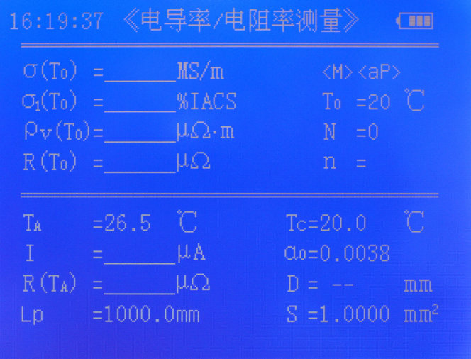
The functions of the parameters at the interface are basically similar to ‘wire parameter meas’ interface, except three measuring parameters. Here there is no user-set parameter G’. The other two different measuring values are listed below.
- σ（T₀）——conductivity at standard temperature 20℃, unit: MS/m
- σ ₁（T₀）——conductivity at standard temperature 20℃, unit: %IACS
While operating the interface, please refer to the method of wire comprehensive parameter measurement.

5.3.4 DC resistance meas
Set the main interface to ‘DC resistance meas’ as illustrated below. (see 5.4.2 for detailed setting method)
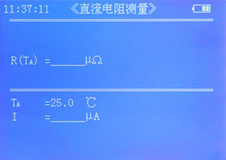
The interface is only for measuring ordinary small four-terminal resistors. The measured values cannot be saved and printed.
While operating the interface, please refer to the method of wire comprehensive parameter measurement.

5.3.5 Conduc DC resist meas (only for B model)
Set the main interface to ‘conduc DC resist meas’ as illustrated below. (see 5.4.2 for detailed setting method)
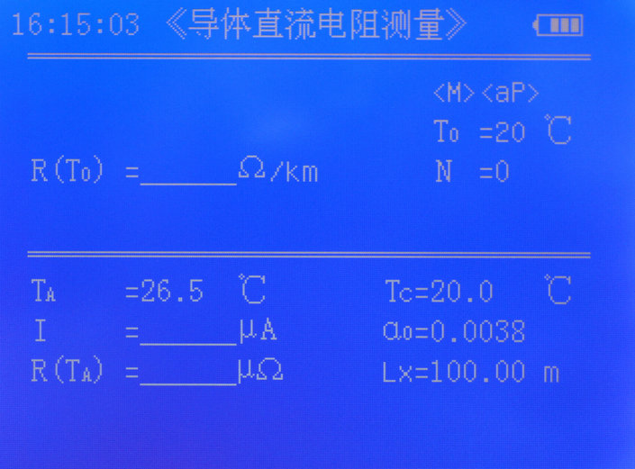
The functions of the parameters on the interface are basically similar to ‘wire parameter meas’ interface, except the following different measuring parameters.
- R（T₀）——measured resistance of wire and cable with one-thousand-meter length at temperature 20℃, unit: Ω/km
- R（T_{A}）——measured resistance of the cable with length L_{K} at temperature T_{A}, units: Ω, mΩ, µΩ
- L_{X}——measured length of the sample (length of finished cable but not the length of single insulated core), unit: m
The interface is suitable for measuring direct-current resistance of wire/cable. The measured values can be saved and printed.
While operating the interface, please refer to the method of wire comprehensive parameter measurement.

5.3.6 Settings
On measurement main interface, press ‘SET’ key to enter parameter-setting state. Use ‘↑’ or ‘↓’ key to select parameters that need to be set. The selected parameter will flicker with reversed display. If a parameter needs to be set, press ‘OK’ key to enter the setting process. Here the parameter value shows reversed display. Pressing ‘ESC’ key, the system will exit the setting state and return to the measurement main interface.
The parameter with reversed display can be set. After setting, press ‘OK’ key to save and move to the next parameter. If press ‘ESC’ key after setting, it will exit without saving and the parameter will resume to the previous value. After finishing setting, press ‘ESC’ key to exit setting state and return to the measurement main interface.

5.3.6.1 Setting temperature coefficient α₀
While setting temperature coefficient α ₀, the figure has reversed display. Use ‘↑’ or ‘↓’ key to select one of the four values of the temperature coefficient saved at ‘Temp. coeff set’ in ‘menu’. Then press ‘OK’ key to save.

5.3.6.2 Setting diameter D and sectional area S
While setting diameter D and sectional area S, the figure has reversed display. Use numerical key to enter new value or use ‘DEL’ key to delete entered value, then press ‘OK’ key to save the value. Within D and S, only one item is effective, the other item will automatically set to zero and displays as ‘--’. There are 5 effective digits for D and 6 for S.

5.3.6.3 Setting unit mass G’
While setting unit mass G’, the figure has reversed display. Use numerical key to enter new value or use ‘DEL’ key to delete entered value, then press ‘OK’ key to save the value. There are 5 effective digits for G’. Parameter G’ is only shown on ‘wire parameter meas’ interface.

Setting compensation temperature T_{C}
While setting compensation temperature T_{C}, the figure has reversed display. Use numerical key to enter new value or use ‘DEL’ key to delete entered value, then press ‘OK’ key to save the value. There are 3 effective digits for T_{C}.
T_{A} is the ambient temperature value measured by equipped sensor, while T_{C} is the compensation temperature value, i.e., the real temperature of the conductor. When ‘Temp. coeff set’ in ‘menu’ is selected as the equipped temperature sensor, the temperature value of T_{C} will automatically choose the value of T_{A} and the interface displays ‘T_{C}=T_{A}’. In the situation ‘SET’ key does not function. When selecting to enter temperature value manually, T_{C} value can be set using ‘SET’ key.
Note：
Compensation-temperature parameter T_{C} is used when calculating measured values under standard temperature T₀=20℃. If measured conductor temperature and the ambient temperature measured by equipped temperature sensor are different or the ambient temperature has large variation, it is better to select ‘manual temp. input’ mode to enter T_{C} value directly. If measured conductor temperature and the ambient temperature are balanced, it is better to select ‘equipped temp. sensor’ mode. Here the instrument will automatically choose ‘T_{C}=T_{A}’.

5.3.6.5 Wire/cable length L_{X} (only for B model)
While setting wire/cable length L_{X}, the figure has reversed display. Use numerical key to enter new value, and use ‘DEL’ key to delete entered value, then press ‘OK’ key to save the value. The effective range of L_{X} is 1.000m～10000m, and the maximum effective digit is 5. If the set value exceeds the range, it will not be saved and the previous value will be resumed.
Note：
If using the measuring fixture with 1 meter length, set L_{X} as 1.000m. If selecting special measuring clamps for cable coil, then L_{X} equals to the real length of the cable gripped by the clamps.

5.3.7 Print
The instrument is equipped with a portable mini-printer. When the measurement main interface or data enquiry interface displays measured results, the results will be printed out at once. When using the printer, connect the communication line to RS232 communication interface at the back of the instrument and MINI USB interface on the printer, and press power key P on the printer to turn on the printer. Then, the printer is ready to use.
Refer to appendix 1 for the operation of the portable mini-printer.

5.3.7.1 Manual printing
If on the menu the printer is set as ‘manual’, at the measurement interface and enquiry interface, ‘PRINT’ key is effective. The printer will print out the data on the interface. If another printing is needed, press ‘PRINT’ key again.

5.3.7.2 Automatic printing
If on the menu the printer is set as ‘automatic’, ‘PRINT’ key is ineffective. After every measurement, the printer will automatically print out the data at the measurement interface. If another printing is needed, press ‘PRINT’ key once.

5.3.7.3 Turning off the printer
If on the menu the printer is set as ‘off’, the printing function is cancelled. The ‘PRINT’ key is ineffective, and the screen displays ‘printing function off’ to warn the user.

5.3.7.4 Printing contents
The printing contents are listed in the following.
1．Serial number (number of the saved data group in the instrument)
2．Date and time of the measurement
3．Measuring temperature T_{A}
4．Material parameter
- Diameter D or sectional area S
- Unit mass G’
5．Measuring data
- Volume resistivity ρ_{v}（T₀）or its average value of n times ρ_{v}（T₀）
- Mass resistivity ρ_{m}（T₀）or its average value of n times ρ_{m}（T₀）
- Unit length resistivity ρ_{l}（T₀）or its average value of n times ρ_{l}（T₀）
- Direct-current resistance R（T₀）or its average value of n times R（T₀）
or
- Conductivity σ（T₀）or its average value of n times σ（T₀）
- Conductivity σ ₁（T₀）or its average value of n timesσ₁（T₀）
- Volume resistivity ρ_{v}（T₀）or its average value of n times ρ_{v}（T₀）
- Direct-current resistance R（T₀）or its average value of n times R（T₀）
or
- Resistance of wire/cable per 1000m length R（T₀）or its average value of n times R（T₀）（only for B model）

5.4 Menu
On measurement main interface, press ‘MENU’ key to enter ‘menu’ interface.
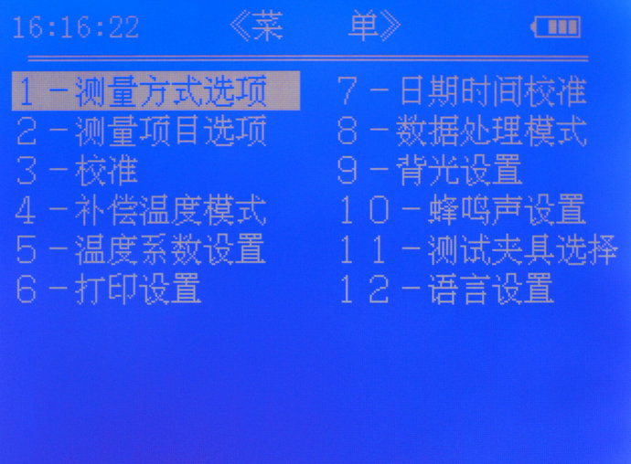
On menu interface, press ‘↑’ or ‘↓’ key to move reversed display to select sub-interface, then press ‘OK’ to enter the selected sub-interface. If press ‘ESC’ key, it will return to measurement main interface. In addition, numerical keys ‘1~9’ are the shortcut to the corresponding sub-interfaces. Pressing single numerical key can enter the corresponding sub-interface directly.

5.4.1 Sub-interface of Meas mode option

5.4.1.1 Selecting measuring mode
There are four options for measuring mode selection. The reversed display remains at the previous selection. Use ‘↑’ or ‘↓’ key to move reversed display to select measuring mode, then press ‘OK’ key to confirm and save. The square of the selected item will have the mark ‘√’ , then the system returns to the main menu.
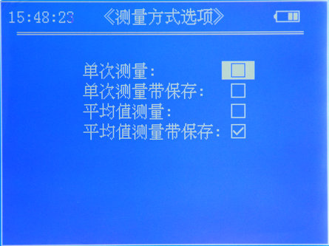

5.4.1.2 Setting average frequency
If select ‘measuring average value’ or ‘save average meas value’, press ‘OK’ key to enter ‘average frequency’ sub-interface. Use numerical key to enter the average number of times within the range ‘2~99’, then press ‘OK’ key to confirm and return to the main menu.
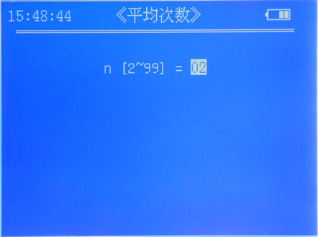
Note：
- When selecting single measurement with saving or average value measurement with saving, at the upper right of the measurement main interface, it shows ‘<M>’. After each measurement, the data group will be saved once. At the same time, N=XXXX is shown to indicate the serial number of the data group.
- The earlier saved data group has lower serial number, i.e., the serial number of the first saved data group has N=1, the next serial number of the data group has N=2, and so on. When 1000 data groups have been saved, <F> will be shown to remind users to delete saved data groups so as to maintain active saving function.
- When the measuring mode is the average value of n times, only when n measurements have been done and the instrument shows the measuring parameters are average values, the data group can be saved.

5.4.2 Sub-interface of Meas item option
Selecting different measuring item can change measurement main interface to meet the requirements of each measurement.
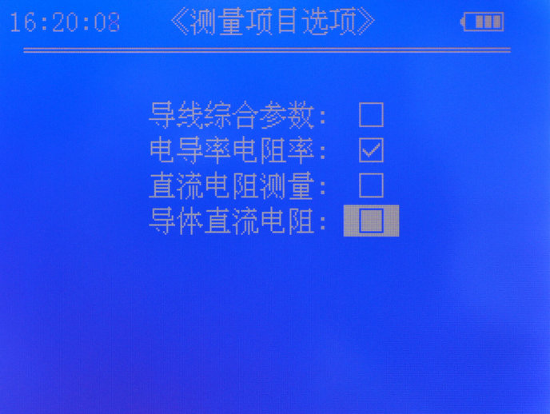

5.4.2.1 Introduction of the measurement main interface for measuring wire comprehensive parameter
On the wire-comprehensive-parameter measurement main interface, the displayed measuring values are: ρ_{v}（T₀）- volume resistivity at standard temperature 20℃; ρ_{m}（T₀）- mass resistivity at standard temperature 20℃; ρ_{l}（T₀）- unit length resistance at standard temperature 20℃; R（T₀） - resistance of the sample with the measured length between the two potential clamps at standard temperature 20℃.

5.4.2.2 Introduction of conductivity/resistivity measurement main interface
On the conductivity/resistivity measurement main interface, the displayed measuring values are: σ（T₀）- conductivity at standard temperature 20℃; σ ₁（T₀）- conductivity at standard temperature 20℃; ρ_{v}（T₀）- volume resistivity at standard temperature 20℃; R（T₀）- full length resistance measured at the two ends of the sample at standard temperature 20℃.

5.4.2.3 Introduction of DC resistance measurement main interface
On the direct-current resistance measurement main interface, only direct-current resistance R（T_{A}） is shown.

5.4.2.4 Introduction of the measurement main interface of conductor DC resistance
On the conductor direct-current resistance measurement main interface, the measuring value on display is R（T₀）- resistance of wire/cable with one kilometer length at standard temperature 20℃, unit: Ω/km.

5.4.3 Sub-interface of Calibration

5.4.3.1 Calibration security code
On the following illustration of calibration sub-interface, enter security code ‘123’ then press ‘OK’ key to confirm. The sub-interface of standard resistance is on display. If press ‘ESC’ key, it will return to the menu.
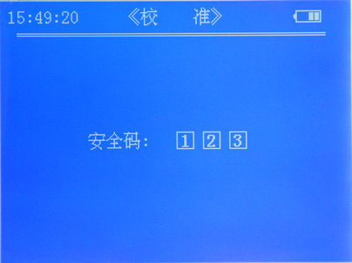

5.4.3.2 Setting standard resistance
On the sub-interface of standard resistance as illustrated below, enter the value of standard resistance using numerical keys directly and press ‘OK’ key to confirm and save the value. Then connect the standard resistor to the measuring fixture according to the instruction shown on the interface and press ‘OK’ key again to start calibration.
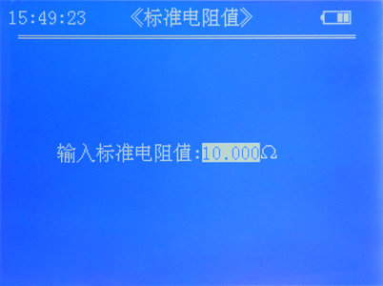

5.4.3.3 Attention
After finishing calibration, the instrument will display ‘calibration finished’ and save the new calibration value automatically. Press ‘ESC’ to return to the menu. If it displays ‘calibration failed’, make sure the entered standard resistance value is correct and the connection of the standard resistor is reliable, then start the calibration again. If during the calibration a problem is indicated, the user can solve it according to the instruction.
Note:
- The calibration is for the internal system of the instrument. Usually such calibration is not advocated in order to avoid personal error, because the calibration will change the settings made by the factory.
- When the instrument is under regular inspection or has accuracy error (when the error measured using instrument equipped standard calibration resistor ≥ 0.1%), user can calibrate the instrument according to standard calibration resistor.
- Usually the calibration is required to be carried out at ambient temperature 20±5℃ and relative humidity 0～80%.
- While fixing the calibration resistor, avoid touching the resistor with hand for long time.

5.4.4 Sub-interface of Temp. comp mode
If ‘manual temp. input’ is selected, T_{C} temperature value on measurement main interface can be entered manually using ‘SET’ key. If ‘equipped temp. sensor’ is selected, there is no need to enter T_{C} value manually and the value will be automatically picked.

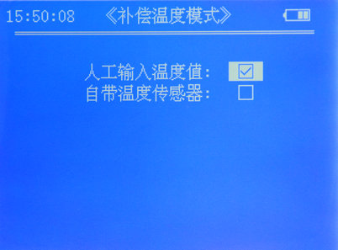

5.4.5 Sub-interface of Temp. coeff set

5.4.5.1 Entering temperature coefficient value
As illustrated below, temperature coefficient has ‘α ₀~α ₃’ four options. When reversed display is on α _{n}, numerical keys can be used to alter the value. When there is an error on entered figure, use ‘DEL’ key to delete it. If the present value does not need any change, use ‘↑’ or ‘↓’ key to select other temperature coefficients that need to alter. After altering, press ‘OK’ key to save the value and return to the menu. If press ‘ESC’ key, it will return to the menu directly without saving the altered values.
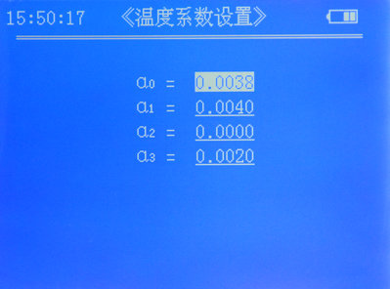

5.4.5.2 Range of temperature coefficient
The effective range of temperature coefficient α _{n} is 0.0000～0.0300. If the set value exceeds the range, it will not be saved and the previous value will be resumed.
Refer to appendix 2 for temperature coefficients of different conductors.

5.4.6 Sub-interface of Printing setting
Prior to printing the data, select ‘manual’ or ‘automatic’. If there is no need to print, select ‘off’. Use ‘↑’ or ‘↓’ key to select wanted item, then press ‘OK’ to confirm and save the setting, and return to the menu interface. If press ‘ESC’ key, it will return to the menu interface directly without saving the setting.

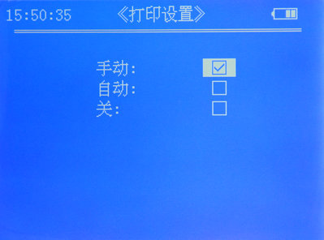

5.4.7 Sub-interface of Date/time adjust
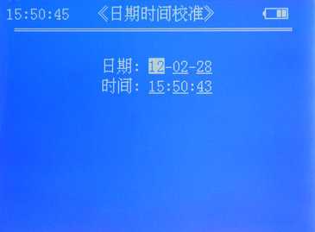

5.4.7.1 Forms of date and time
The form of date is ‘year-month-day’. The range of year is 2000 ~ 2099. Only the last two digits of year are shown, such as ‘2010’ only shows ‘10’. The form of time is ‘hour : minute : second’.

5.4.7.2 Entering date and time
Reversed display indicates the item that can be altered. Use ‘↑’ or ‘↓’ key to select the item that needs to alter and use numerical key to enter the value. If more than two digits have been entered to the same item, the first entered digit will be automatically deleted. If entered date exceeds the range, after pressing ‘OK’ key, the value will not be saved and the previous value will be resumed.

5.4.8 Sub-interface of Data handle mode
There are three modes for handling data: data uploading, data searching and data deleting.
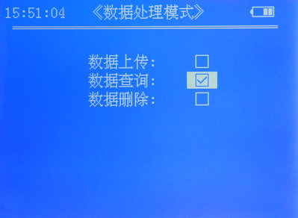

5.4.8.1 Data uploading
Data uploading is to upload the measured data saved in the instrument to the host computer according to user’s requirements. Before uploading the data, the data-uploading line must be connected correctly. Open the data-uploading software in the host computer and select connected serial number, then press ‘start to receive’ and wait for the instrument to upload required data to the computer.
Select ‘data uploading’ and press ‘OK’ key to set ‘uploading date’. Uploading date includes starting date and ending date. The form of date is ‘year-month-day’, and the setting method is the same as ‘Date and time adjust’. After entering the dates, press ‘OK’ key. The instrument will display ‘under querying’ and start to search the saved measuring data between the starting date and the ending date. If the saved data according with the inquiry dates are found, the instrument will upload the data. When the uploading finishes, it will display ‘uploading finished’. If no data according with the dates is found, it will display ‘no data’.
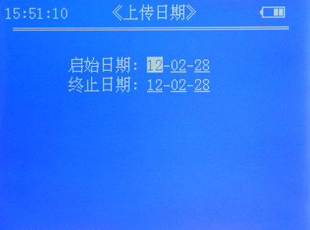

5.4.8.2 Data query
Data query is to search the measured data groups saved in the instrument according to the inquiry dates and display the data. Select ‘data query’ and press ‘OK’ key to enter ‘inquiry date’ to set the dates with the same way as the uploading date setting. After setting press ‘OK’ key, the instrument will display ‘under querying’ and start to search the saved measuring data between the starting date and the ending date. If the saved data according with the inquiry dates are found, the instrument will display the first data group. If the data according with the inquiry dates are not found, it will display ‘no data’.
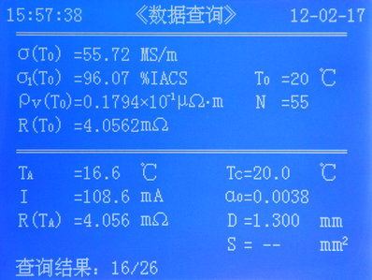
On above data query interface display, at the upper left corner and the upper right corner of the screen it shows the measuring time and date of the data are 15 hour 57 minute 38 second and 17th of Feb., 2012 respectively. At the lower left of the screen it shows the searched result and the present display status, such as ‘query results: 16/26’ indicates that 26 groups of the data have been found and the present display is the 16th data group. Press ‘↑’ or ‘↓’ key to see the preceding or next group of data.

5.4.8.3 Data deletion
Data deletion is to delete the measured data already saved in the instrument. Select ‘data deletion’ and press ‘OK’ key, the screen will display ‘confirm to delete all measured data’. Press ‘OK’ key to perform deletion, the saved measuring data will be clear out. If press ‘ESC’ key, the deletion will be canceled, then it will return to the menu interface.

5.4.9 Sub-interface of Backlight set
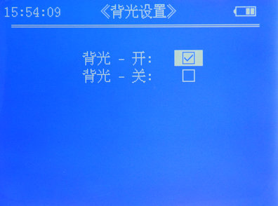
Backlight setting can turn on or turn off the backlight of the screen. When the lighting is insufficient or the screen display is too dim, it is better to turn on the backlight. Use ‘↑’ or ‘↓’ key to select the option then press ‘OK’ key to save the setting. The setting will be effective immediately so that the screen backlight will be turn on or off at once. Then it will return to the menu interface. If press ‘ESC’ key, the setting will not be saved，and it will return to the menu interface directly.

5.4.10 Sub-interface of Buzzer set
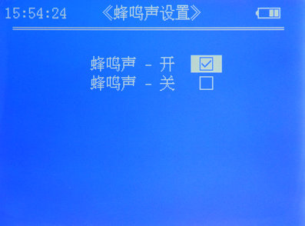
When pressing keys to operate, the buzzer will beep if the measurement is successful or the battery has low voltage.
Note:
If the buzzer setting selects ‘on’, the buzzer beeps once when one key-pressing is effective; when a measurement is finished and the data is effective, the buzzer beeps twice rapidly; when the battery has low electricity, the buzzer beeps three times rapidly, and after 5 minutes it beeps three times again to remind user to charge the battery promptly.

5.4.11 Sub-interface of Language set
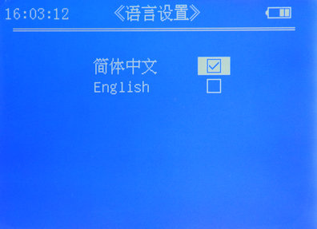
There are two options at language setting: simplified Chinese and English.

5.4.12 Sub-interface of Meas fixt select (only for B model)
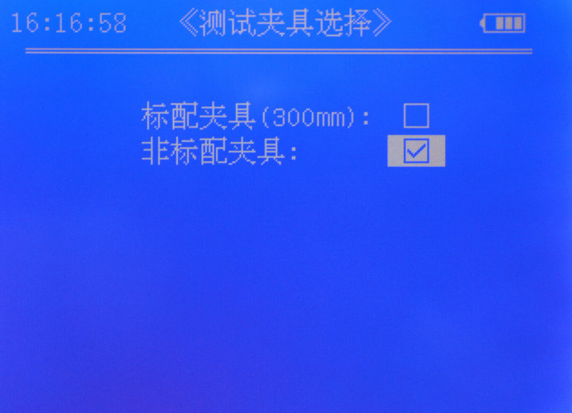

There are two options of measuring fixture: ‘standard fixture300mm’ and ‘non-standard fixture’. When selecting non-standard fixture, press ‘OK’ key to enter ‘fixture length’ setting. Enter the length value of the fixture, then press ‘OK’ key to save the setting and return to the menu interface. At the corresponding measurement main interface, the value of the fixture length ‘L_{p}’ will be shown.
The effective range of the measuring fixture length ‘L_{p}’ is 100mm～1500mm. There are 5 effective digits. If the set value exceeds the range, it will not be saved, and the previous value will be resumed.
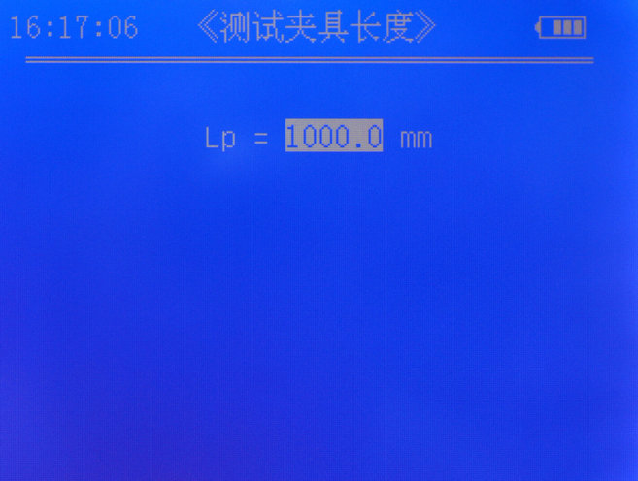
The selection of measuring fixture is only effective at the main interfaces of ‘wire parameter meas’ and ‘conduc/resis meas’.

5.5 Charging battery
The originally equipped battery of the instrument is 7Ah/7.4V lithium battery. If the battery supplies power alone, the average working time is over 15 hours.
The instruction for low electricity is 0 grid display, and the buzzer will make 3 beeps in every 5 minutes to remind user to charge the battery promptly. If charging battery is not carried out promptly, after about 30-minute warning the instrument will be switched off automatically.
Charging method: Insert the instrument equipped charger into 100V～240V AC power supply, and insert the DC plug of the charger into DC socket of the instrument. Here the red indicator light of the charger will be lit, indicating that the battery is charging. When the red light of the charger turns into green, the battery is fully charged. Then pull out the DC and AC plugs.

6 Attentions and maintenance
- The measurement must be carried out under 0～40℃ temperature and 0～80% relative humidity.
- While conducting calibration or measurement, make the best to handle the measuring fixture smoothly and steadily.
- Should not touch the clamps of the measuring fixture with hands for long time, otherwise the temperature of the clamps will rise so that the measuring accuracy will be affected.
- While conducting the measurement, make the best to keep the measuring conductor, measuring fixture and the instrument under the ambient temperature with very low variation.
- If the measuring conductor and the measuring fixture are covered with dirt, such as oil and dust, they must be cleaned up at once.
- The instrument and the measuring fixture must be used and kept in the environment without corrosion, vibration and electromagnetic field.
- The potential clamps of the measuring fixture must be replaced if they have been worn seriously, to avoid lowering measuring accuracy.
- The instrument and the measuring fixture must be prevented from vibration, collision and serious scratching.
- While conducting measurement, make the best to keep away from radiator and oven, and avoid direct sunlight.
- Never use fingers to touch temperature sensor.

7 User notice
1．The warranty period of the instrument is one year.
2．Under the following situations, the company and the company authorized agencies have no responsibility for free maintenance. However paid maintenance is still available.
- Working failure or breakdown of the product caused by not connecting, using, maintaining and keeping the product according to the operating manual;
- Beyond the warranty period;
- The serial number on the warranty card of the product does not accord with that of the product itself;
- The host and components that have been taken apart then assembled or repaired by professional maintenance personnel who do not belong to the company or are not authorized by the company;
- The components without maintenance guarantee (measuring fixture, charger, chargeable battery, shell, keyboard, connecting line, printer);
- Damages on the product caused by accident or personal mistakes;
- Breakdown or damages of the product caused by irresistible factors, such as earthquake and fire.

Appendix 1: Introduction of printer operation
Paper loading
The printer has easy-paper-loading structure. Use fingers to hold the two sides of the cover of the paper container to open. Put a role of thermal paper into the container, with glossy face down. Reveal the end of the paper role, and then close the paper container. The requirement of the thermal paper is 58mm width and less than 33mm diameter.
Turning on the printer
P is the power button. Under battery power supply, pressing P button once will turn the printer on, and pressing the button once again will turn it off. Under adapter power supply, the printer is always on, and P button is ineffective.
Paper feeding
F is the paper feeding button. When the printer is on, press F button to feed paper, release the button to stop paper feeding.
Self test
When the printer is off, hold down F button then press P button. Release the tow buttons at the same time, the printer will enter self-test state. At this moment the printer will print out the information of printer model, communication mode, etc.
Explication of the printer states
The indicating lights at the left side of the printer indicate the states of power supply, while the lights at the right side indicate the states of being ready, out of paper and standby. Under battery power supply, the printer enters standby state immediately after being turned on. Under adapter power supply, there is no standby state and the printer is always ready.
The printer has two charging modes: fast-charging mode and standby-charging mode. If inserting the adapter while the printer is off, the printer will enter fast-charging mode. Under this mode, the present battery condition will not be checked and the charging process will start directly. Here all buttons of the printer are ineffective. When there is data coming at the printer interface, the printer will resume to the printing state. If inserting the adapter while the printer is at standby state, the printer will enter standby-charging mode. Here the condition of the battery will be checked. Only when the voltage is nearly insufficient and there have been no data coming in for 10 minutes, the printer will enter charging state.
When turning on the printer, the buzzer will beep three times to indicate starting up. When the adapter is connected to the printer, the buzzer will make transient music to indicate the connection. See the following table for detailed indication of printer states.

Power supply  States | Battery |  | Adapter
 | Indicating light | Buzzer | Indicating light | Buzzer
Standby | Right green light flickering | -- | Right green light on | --
Printing | Right green light on | -- | Right green light on | --
Out of paper | Right red light flickering | 2 beeps/5s | Right red light flickering for 2 seconds | 2 beeps/5s
Low electricity | Left red light flickering | 1 beep/5s | Left red light on | --
Sufficient electricity | No indication | -- | Left green light on | --
Charging | -- | -- | Right yellow light flickering for 1 second | --
Note: The buzzer will perform three times, and then stop.

Appendix 2: Table of the conductivity and temperature coefficient of commonly used materials

Metal | Conductivity（20℃） |  | Temperature coefficient  （reference value）  （20℃）
Metal | %IACS | MS/m | Temperature coefficient  （reference value）  （20℃）
Copper | 100 | 58 | 0.0038
Aluminium | 61 | 35.4 | 0.0040
Gold | 70.7 | 41 | 0.0034
Silver | 108 | 62.5 | 0.0038
Brass | 25 | 14.5 | 0.0020
Albronze | 9 | 5.2 | 0.0005
Titanium | 3.6 | 2.08
Lead | 7.8 | 4.5 | 0.0039
Zinc | 30 | 17.4 | 0.0037
Nickel | 22 | 12.8 | 0.0060
Magnesium | 38 | 22 | 0.0040
Average value |  |  | 0.0026

Xiamen Tianyan Instrument Co. Ltd.
Address: 617 Pioneering Building, Pioneering Park, Xiamen Torch High-Tech Development Zone, Xiamen, China
Postcode: 361009
Website: www.xmty1.com
Email: tianyan617@163.com, xmtianyan@126.com
Fax: +86-(0)592-3195307
Sales Tel: +86-(0)592-3195306, +86-(0)592-3195308
24 hour Tel: +86-18050108768, +86-18060926989
Technical support: +86-(0)592-3195309

